Step 1:

Login to portal with following URL

<https://portal.azure.com/#home>

Step 2:

Choose Recovery Services Vault

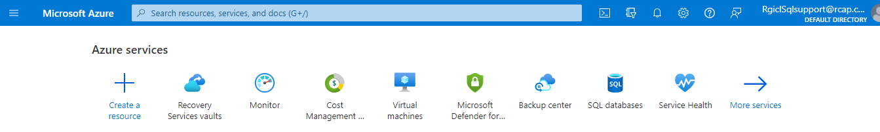

Step 3:

Choose vault **RGISQLDBBACKUP** for DC backup items: (**RGISQLDBBACKUP-DR** for DR backup items)

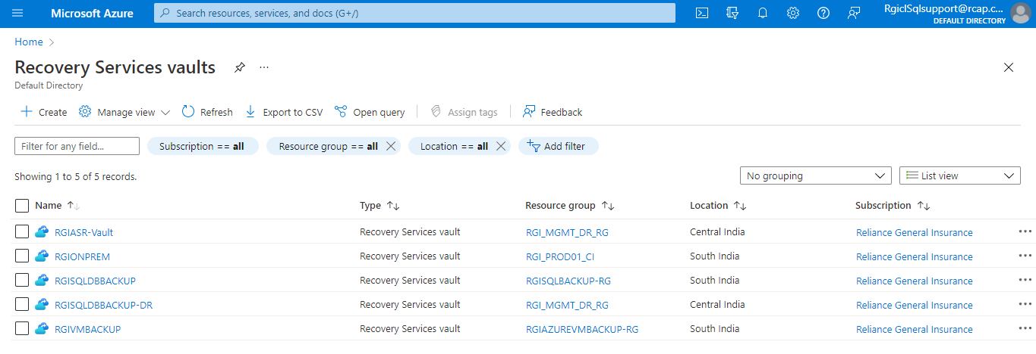

Step 4:

Open backup policies:

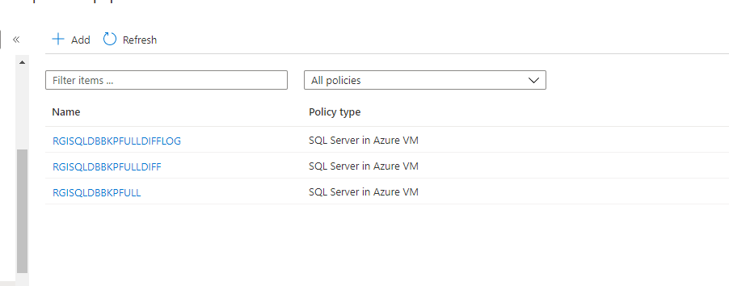

Step 5:

Add new policy and choose SQL Server in Azure VM as policy type:

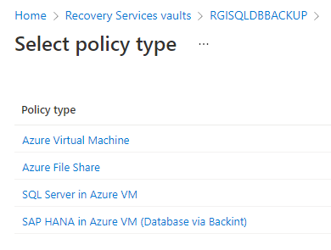

Step 6:

Provide name of new policy as per RGI standards and create the policy as per requirement:

